Tree of the Year Celebration
Honouring “Henry”, American Elm ~
2026 Tree of the Year in Erin

Visual ART SHOW Guidelines

- Artwork submitted for jurying must be original, visual artists interpretation/creativity/expression of “Henry” - American Elm, Erin Tree Trust’s Tree of the Year. For photos of the tree and location please visit the website. https://treetrust.ca/erin/. Henry is currently marked with a red sash and king crown wrapped around its 100+ year old trunk!.

- A maximum of 2 entries per artist. Please keep in mind that the number of works accepted will be limited to the size of work and available gallery space. For 3-dimensional work, there are limited plinths/pedestals or shelves for works including: ceramics, turned wood, mixed media and glass. Please provide your own presentation supports.

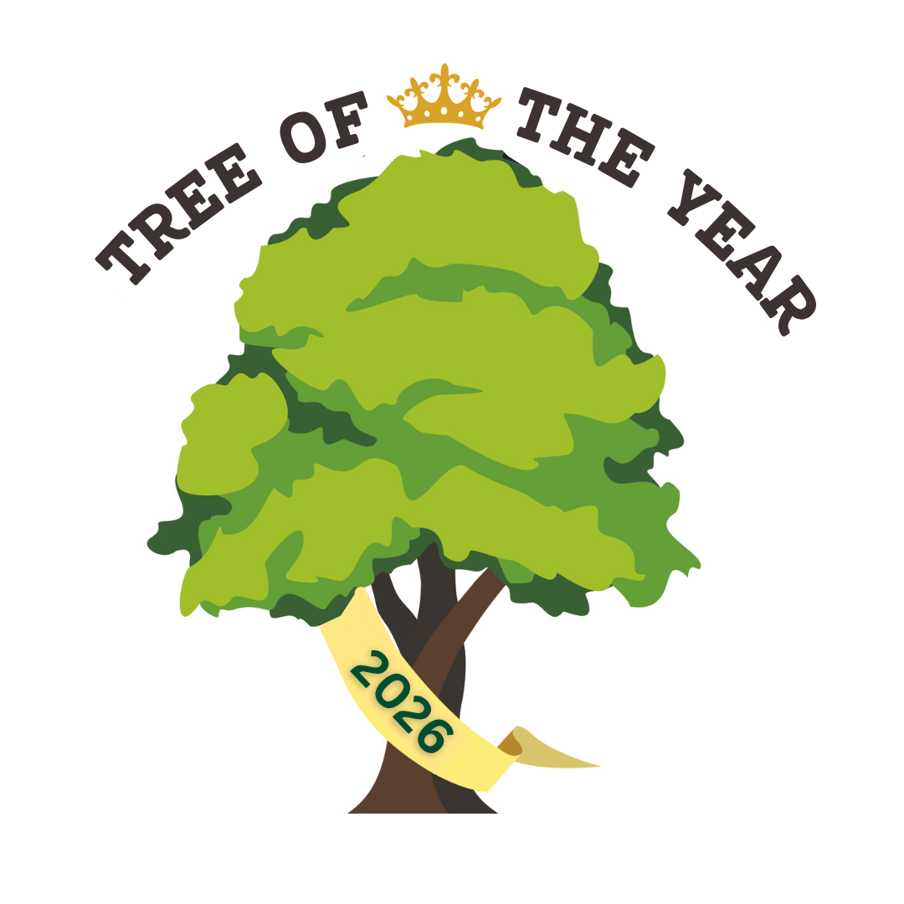
- Art images should be in the form of jpegs. The jpegs should be 1024 pixels on the largest dimension. The file size per artwork must be less than 1.5 MB or 1500 KB. Each Jpeg file must include the artist’s name, underscore, title, underscore, medium, underscore and size (height by width by depth) in inches. For example: JohnSmith_TheShadowsofSummer_oil_36x30x1.5.jpg

- There is NO commission taken should your work sell at the Celebration on September 19, 2026 or when the show moves to the Art Wall in the Town of Erin’s municipal office until mid-late October.

- All work requiring hanging must be equipped with proper wire for hanging and the wire securely fastened.

- Artists are responsible for their own insurance coverage of their work.

- By submitting artwork, the artist agrees to allow Erin Tree Trust the right to use their images for promotional purposes.

- All participating artists may receive hand-out materials to promote the Show. An electronic version will also be made available.

- Everybody is encouraged to publicize the Tree of the Year Celebration.

- Submission Deadline: August 15, 2026. Complete the APPLY here form. All form and images are to be submitted digitally.

- Event Date: Saturday, September 19, 2026, 12 pm to 5 pm at the Hillsburgh Library, 9 Station Road, Hillsburgh, Ontario. The art will be exhibited indoors - lower level of the Hillsburgh Library.

- Notice of Acceptance: Acceptances will be emailed by Friday, August 21, 2026. You will receive further detailed information via email regarding drop off times for selected work for the show.

- Hillsburgh Library: There are public washroom facilities available on site,: fully accessible; Food vendors will be on-site; and there is NO Admission fee for the Celebration. Donations are welcomed.

- About Tree of the Year - Henry’s Location: Please see the map on the Erin Tree Trust webpage: https://treetrust.ca/erin/. Fondly known to some in Town as “Henry”, in honour of Henry Koch, a noted horticulturist, eco-activist, and founder of the Elm Recovery Project in Ontario. “Henry lives on Wellington Road HWY 124, this American Elm has withstood the true test of time and seasons and is a definitive landmark to many coming east, into the Village of Erin from Trafalgar Road on HWY 124 or heading out of Town towards Guelph on HWY 124.

- Background: In the 1930’s, American elms and Dutch elms were devastated by the Dutch Elm disease, which wiped out most mature Elm trees across North America. While most were lost, some smaller or younger trees survived as resistant varieties emerged. “Henry” is one such survivor - an enduring and resilient reminder of a once-dominant species that is now far less common. American Elms are the most stately trees in Eastern Canada. These hardwood trees can reach the height of 125 feet and a diameter of 7’.

- About Erin Tree Trust: Launched in 2025 with generous support from Tree Canada, Tree Trust Erin is one of our newest chapters, dedicated to preserving and protecting mature trees in the heart of southern Ontario. Erin’s rich agricultural heritage, vibrant natural landscapes, and strong environmental values make it an ideal home for the Tree Trust mission. The chapter hit the ground running with its first public event on May 24th, centred around the care of a significant mature tree in the community. Since then, the team has been active across Erin – planting saplings, engaging with residents at the local farmers’ market, and organizing Community Forest Appreciation Day on October 4th. This event brought people together to celebrate the ecological, cultural, emotional, and climate benefits of the town’s treasured trees.

CONTACT INFO:
Susan Powell, Team Manager Erin Tree Trust
s.powell065@sympatico.ca AND/OR erin@treetrust.ca

Hannah Hiemstra, Tree Trust Headquarters; chapters.hannah@treetrust.ca

